1. The Purpose of Analysis for the stock Analysis spreadsheet:

What is Code Refactoring? According to Wikipedia this is how its defined.

**code refactoring** is the process of restructuring existing [computer code](https://en.wikipedia.org/wiki/Computer_code)—changing the [*factoring*](https://en.wikipedia.org/wiki/Decomposition_(computer_science))—without changing its external behavior. Refactoring is intended to improve the design, structure, and/or implementation of the [software](https://en.wikipedia.org/wiki/Software) (its [*non-functional*](https://en.wikipedia.org/wiki/Non-functional_requirement) attributes), while preserving its [functionality](https://en.wikipedia.org/wiki/Functional_requirement). Potential advantages of refactoring may include improved code [readability](https://en.wikipedia.org/wiki/Readability) and reduced [complexity](https://en.wikipedia.org/wiki/Cyclomatic_complexity); these can improve the [source code](https://en.wikipedia.org/wiki/Source_code)'s [maintainability](https://en.wikipedia.org/wiki/Maintainability) and create a simpler, cleaner, or more expressive internal [architecture](https://en.wikipedia.org/wiki/Software_architecture) or [object model](https://en.wikipedia.org/wiki/Object_model) to improve [extensibility](https://en.wikipedia.org/wiki/Extensibility). Another potential goal for refactoring is improved performance; software engineers face an ongoing challenge to write programs that perform faster or use less memory.

<https://en.wikipedia.org/wiki/Code_refactoring>

The purpose of the original code: We created a code to read any stock information and present back to us the total volume for each stock and the annual return in percentage of each of those stock. It is built to quickly analyze as many stocks as given by a data in a very fast and efficient way

The purpose of the second code: VBA Challenge

The purpose of this code is to provide the same result of the original code. However, it is providing the result using the refactoring method. Which is restricting the existing code to improve design, structure and implementation while preserving its functionality, improve code readability and reduce complexity and make it perform faster using less memory.

The provided below images show the live results of the refactoring method

1. Results: Comparison of the results between 2017 and 2018 and the execution time between the original code and the refactored script – using images and examples

**2017 Original Vs. Refactoring (code)**

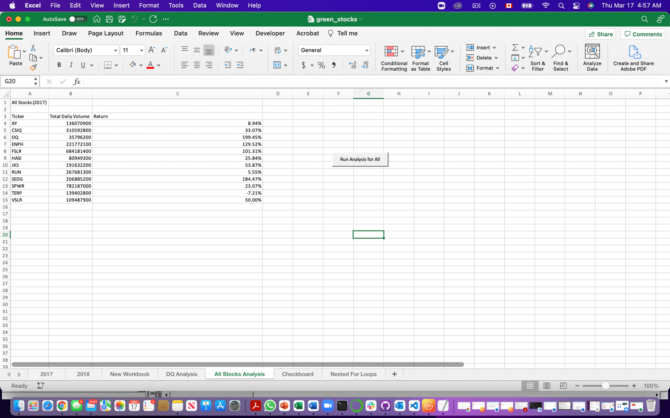

**(Original Result for 2017)**

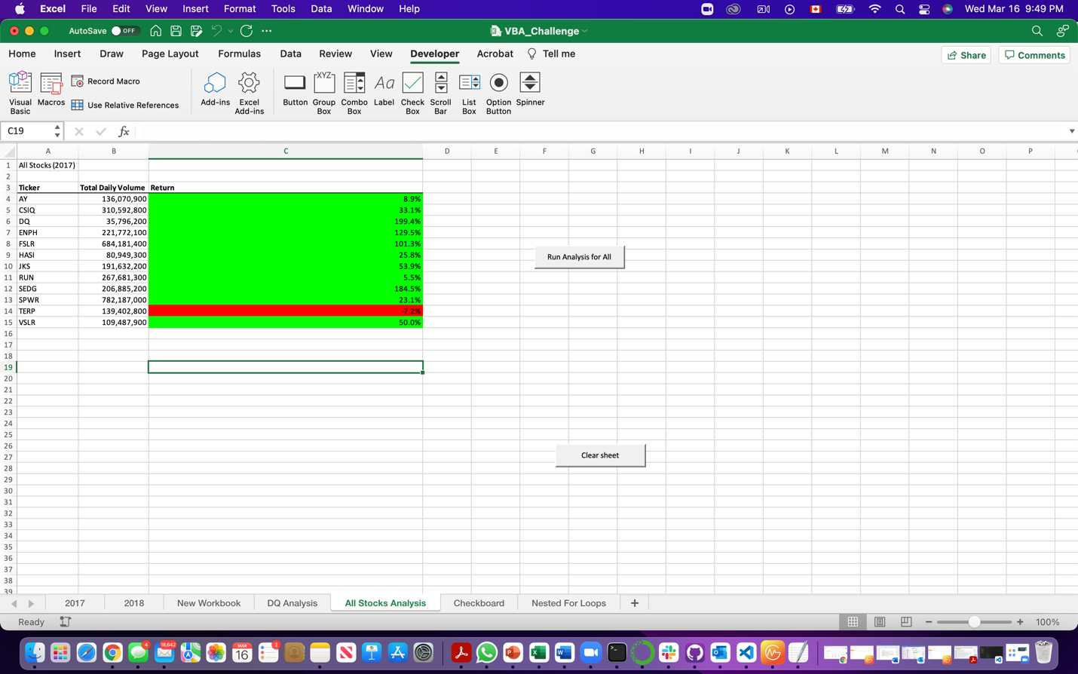

**(Refactored result for 2017)**

2017 Original Vs. Refactoring (timer)

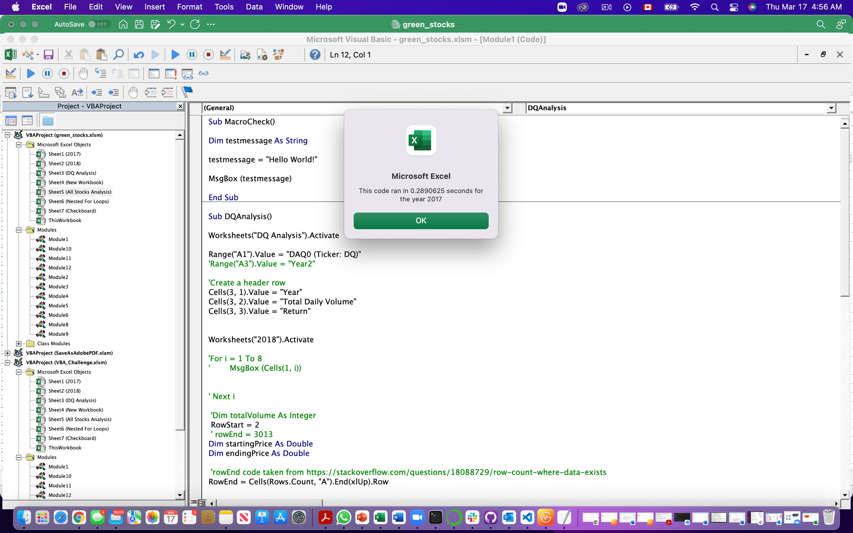

**(Original timer for 2017)**

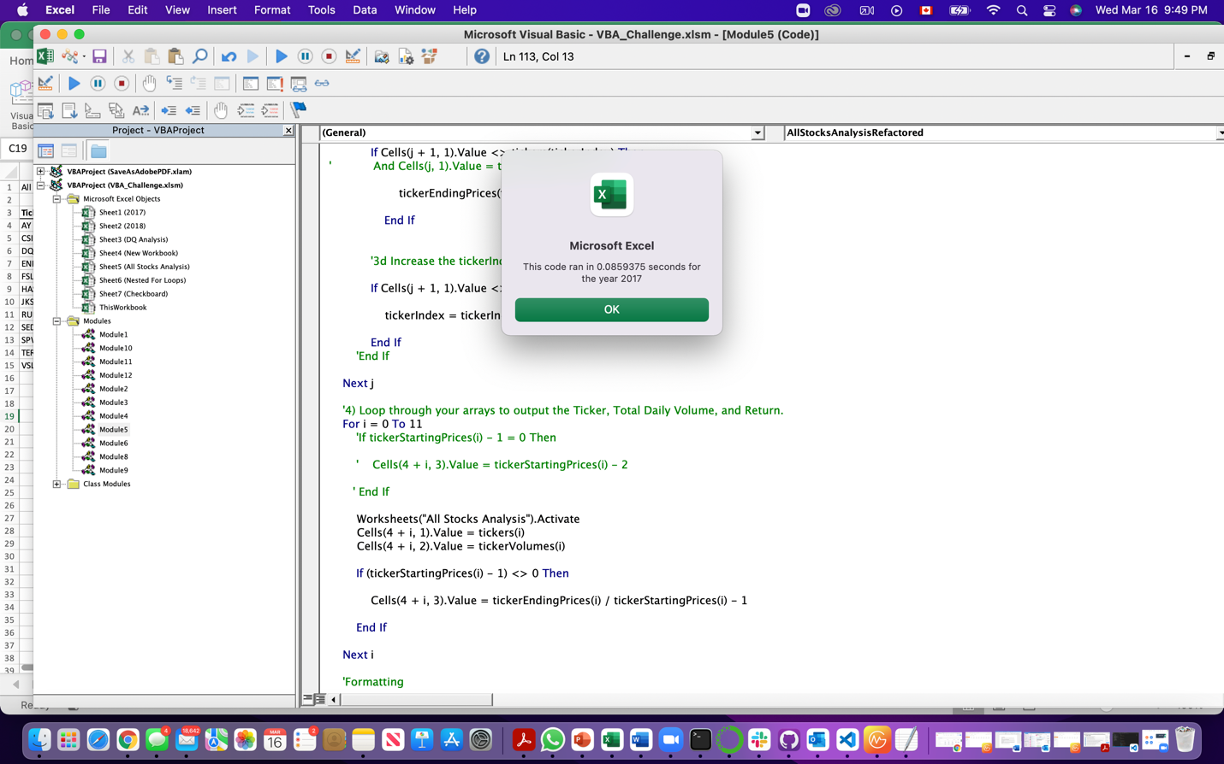

**(Refactored timer for 2017)**

2018 Original Vs. Refactoring (code)

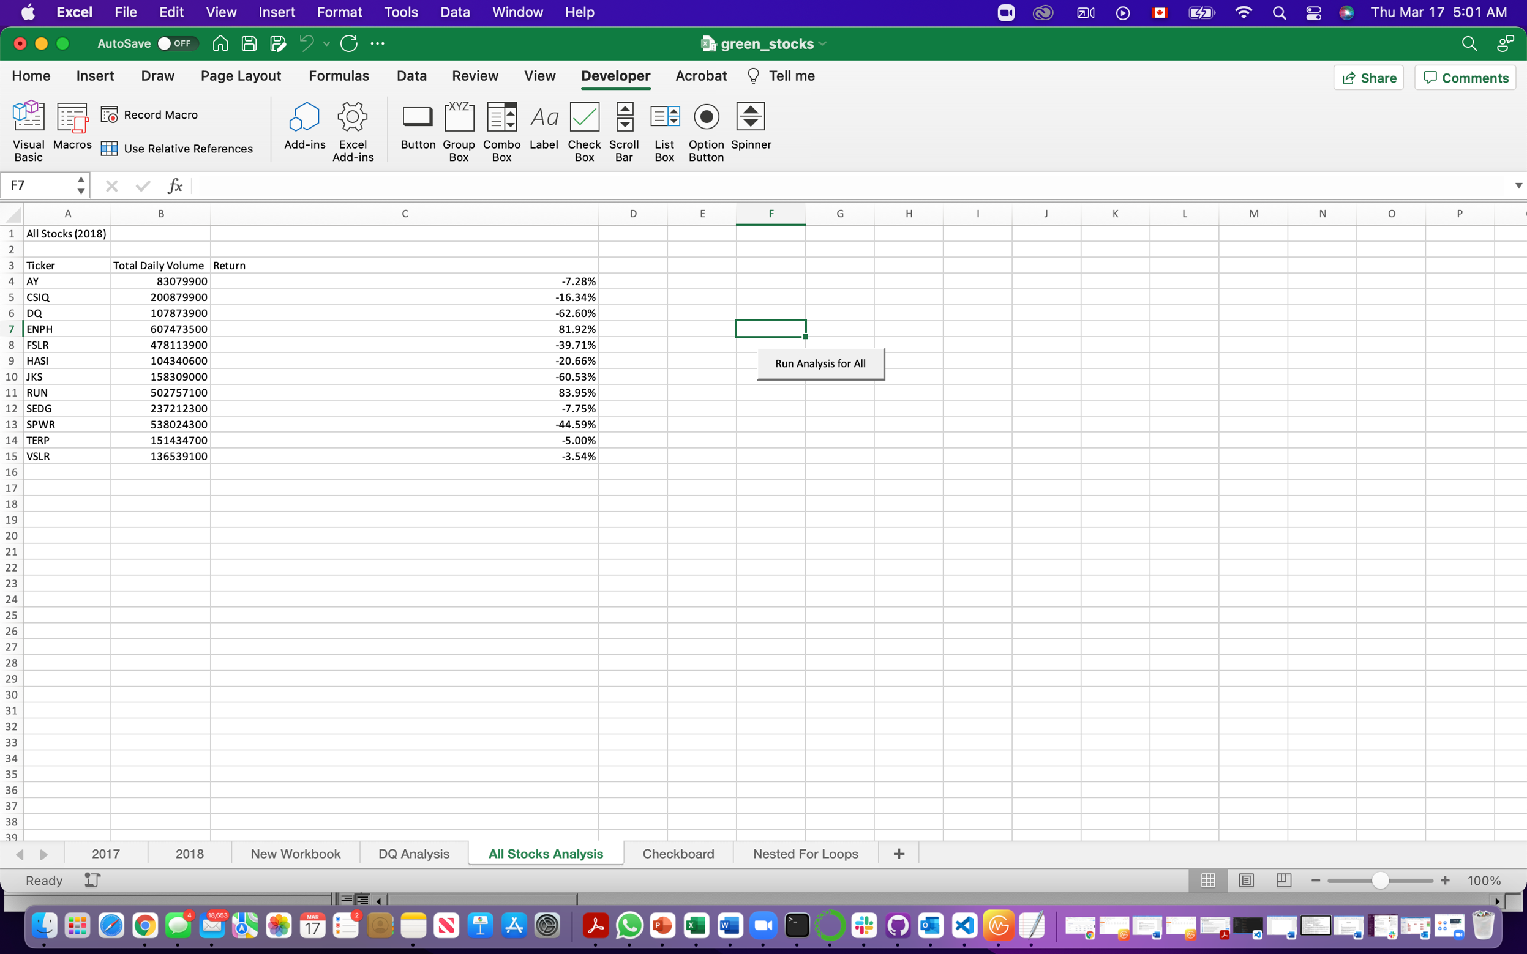

**(Original Script result for 2018)**

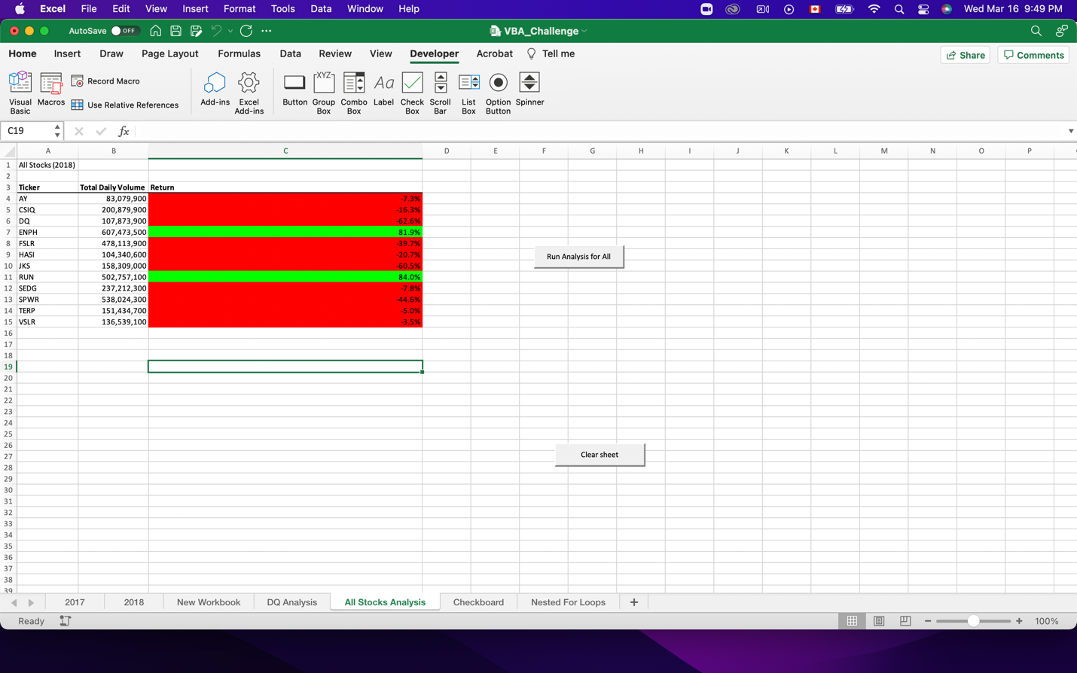

**(Refactored result for 2018)**

**2018 Original Vs Refactoring (timer)**

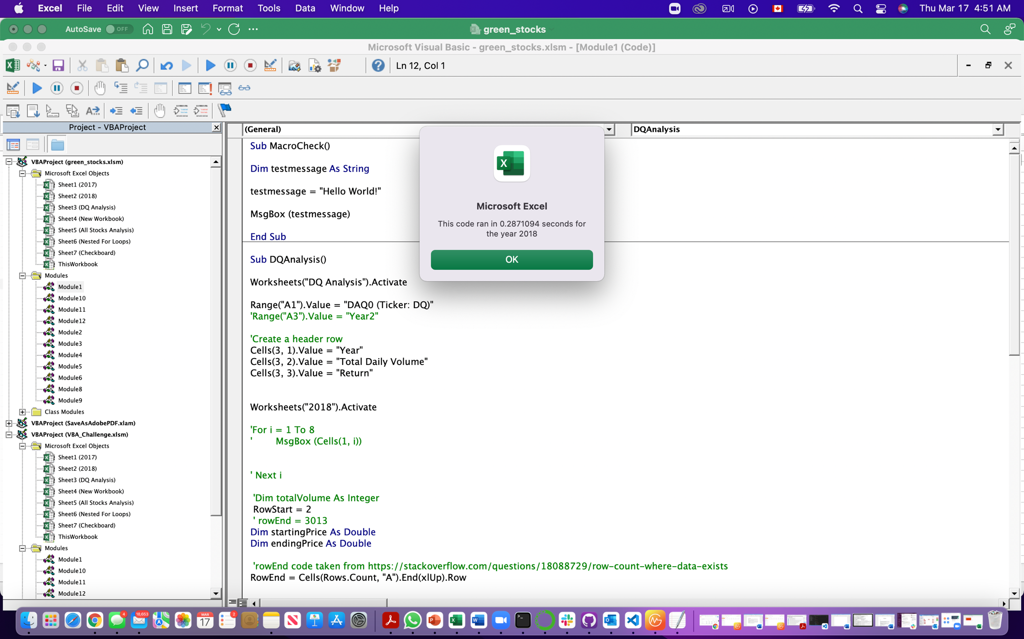

**(Original timer for 2018)**

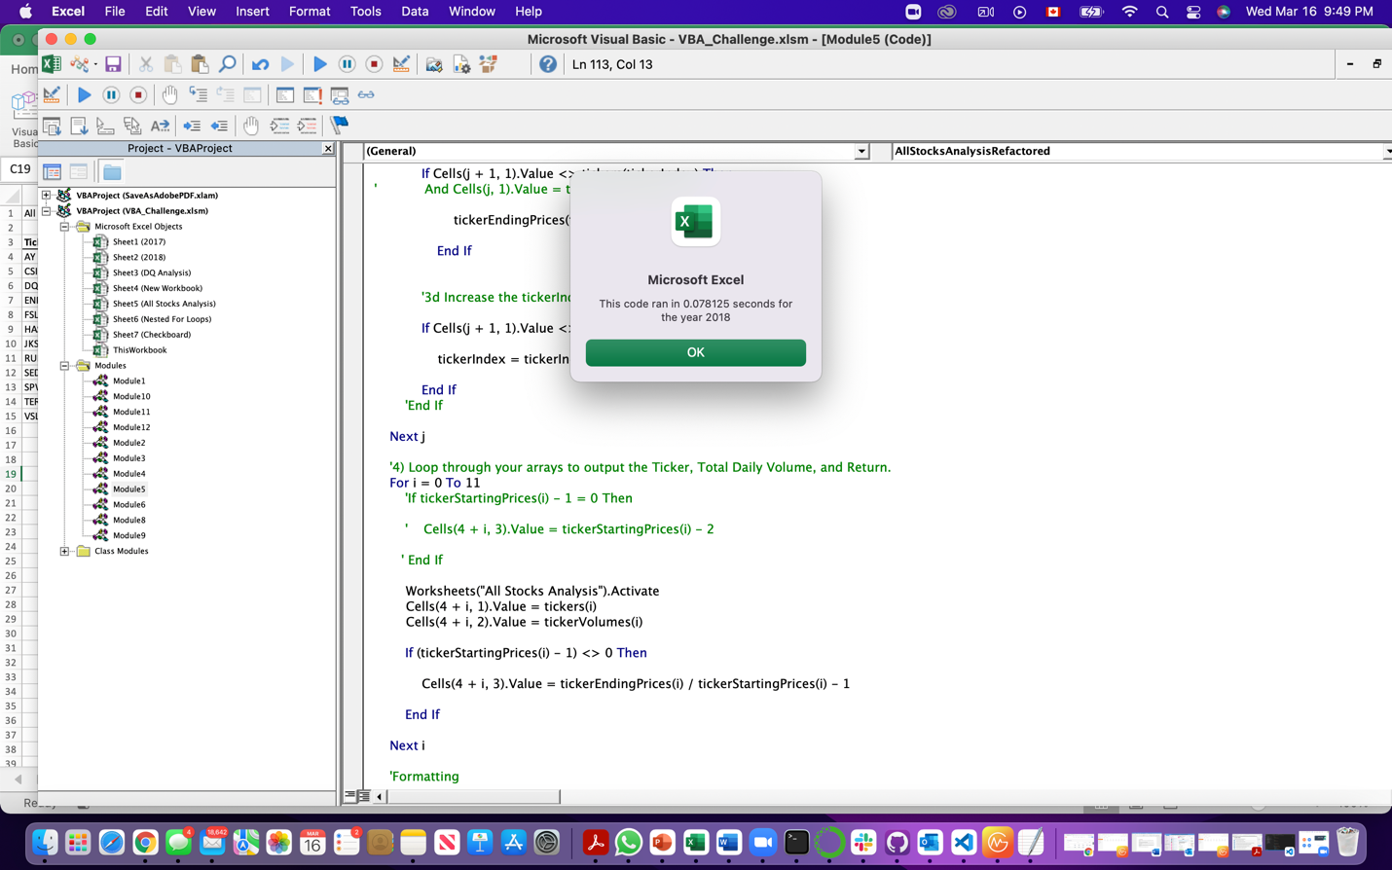

**(Refactored timer for 2018)**

1. Summary:
   1. What are the advantages and disadvantages of refactoring code?

As per the results shown in the images above, we can find that both scripts provided the same results. However, the refactored script provided approve 4 times faster and efficient than the original script

* 1. How do those pros and cons to apply to refactoring the original VBA script?

Refactoring leads to code that is:

* Easier to understand
* Modular
* More maintainable
* Easy to put in more functionality

Cons I can think of are:

* (Not a direct one) Developers write crappy code in the beginning under the pretext of doing refactoring later
* Your system still does that same thing as it was before you undertook the refactoring exercise.